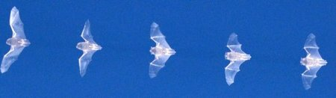

NORFOLK BAT SURVEY

TM0278
Summary: the numbers relate to the number of bat passes rather than necessarily the number of bats.
Bat species = where there is insufficient information to assign the recording to a species or bat family—normally where there is too much noise to pull out a reliable signal or limited acoustic information.
Pipistrelle species = this is where the recording belongs to the genus Pipistrellus, but species identification is not possible.
Myotis species = this is where the recording belongs to the genus Myotis, which in Norfolk includes Natterer’s, Daubenton’s, Whiskered and Brandt’s.

6 June
1 Barbastelle
2 Brown long-eared bat
54 Common pipistrelle
2 Leisler’s
11 Myotis species
2 Noctule
1 Noctule Serotine or Leisler’s
24 Pipistrelle species
129 Soprano pipistrelle
1 Whiskered / Brandt’s - low confidence

17 June
1 Barbastelle
96 Common pipistrelle
1 Leisler’s
12 Myotis species
2 Noctule
1 Noctule Serotine or Leisler’s
18 Pipistrelle species
1 Serotine
131 Soprano pipistrelle

26 June
2 Barbastelle
10 Common pipistrelle
3 Myotis species
3 Pipistrelle species
1 Serotine
19 Soprano pipistrelle

Example species plots

Barbastelle
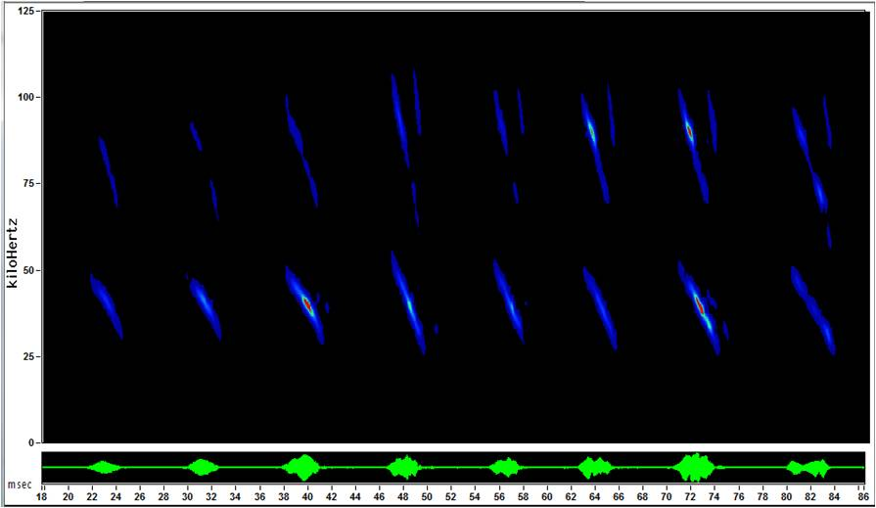

Brown long-eared bat—sweeping down to about 25 kHz
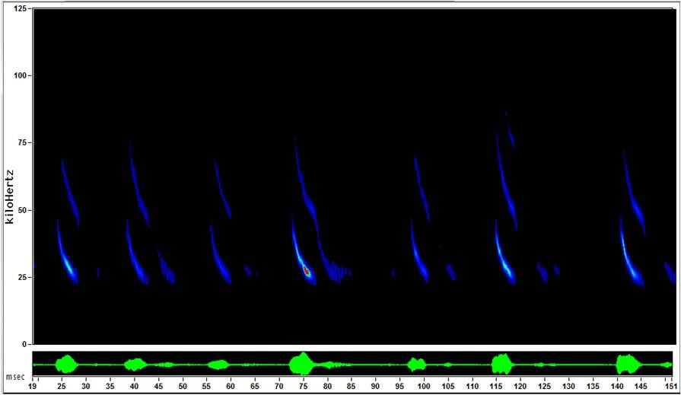

Common pipistrelle—peak frequency about 45 kHz
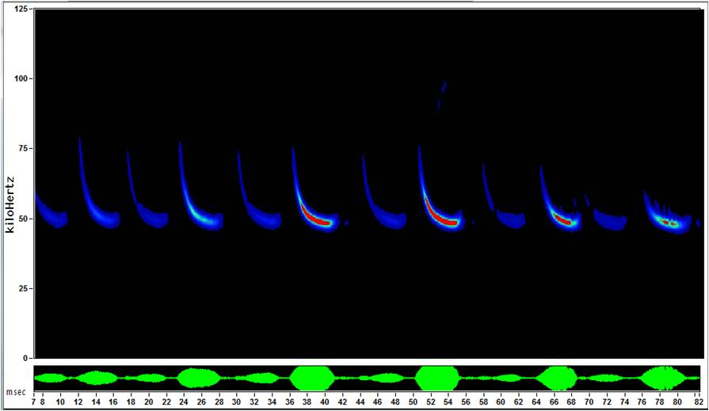

Leisler’s
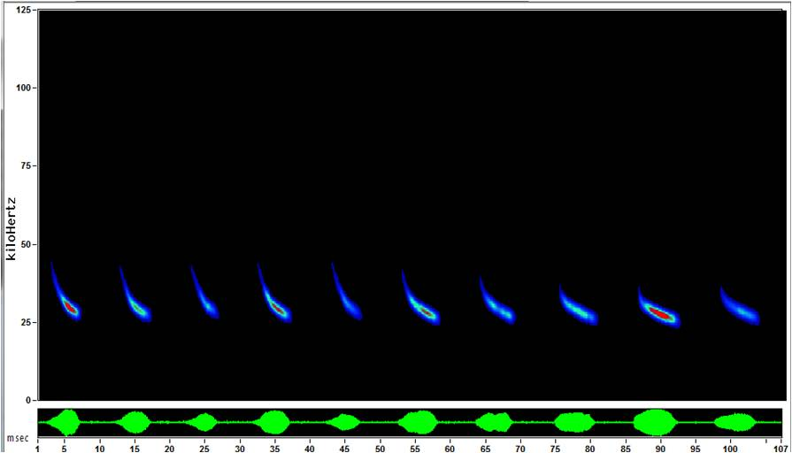

Myotis species—long sweeping calls (Daubenton’s shown below)
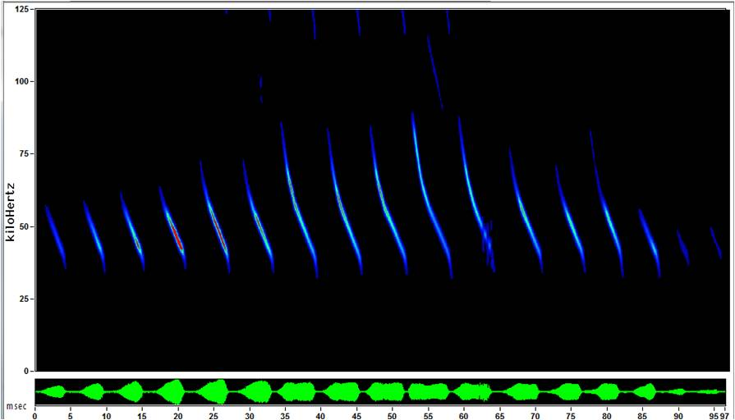

Noctule
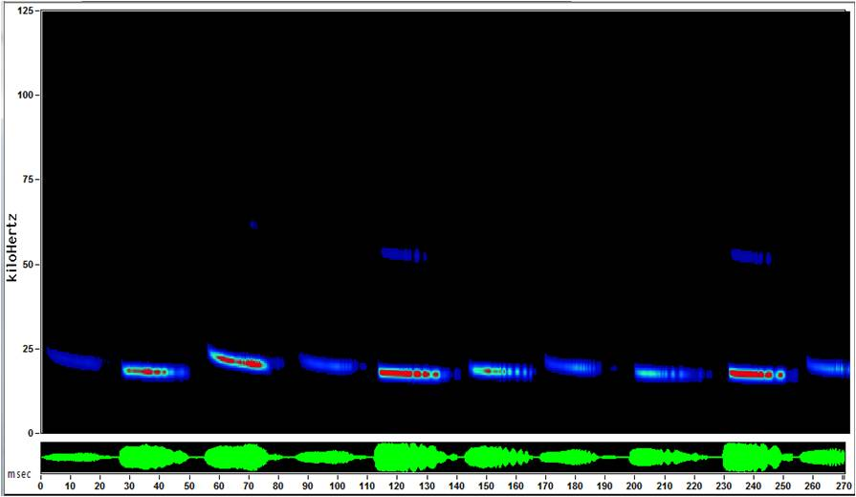

Serotine : fewer than 30 records / year submitted to NBIS (local records centre)
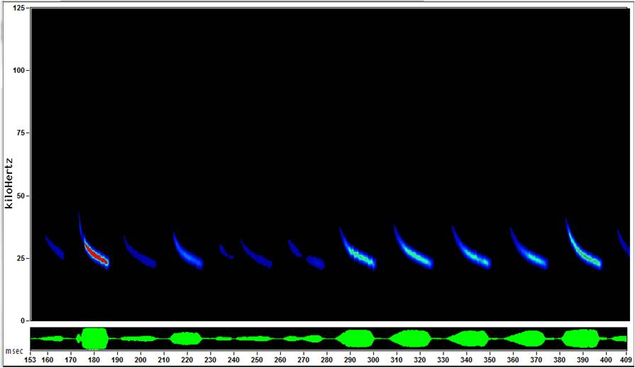

Soprano pipistrelle—peak frequency about 55 kHz
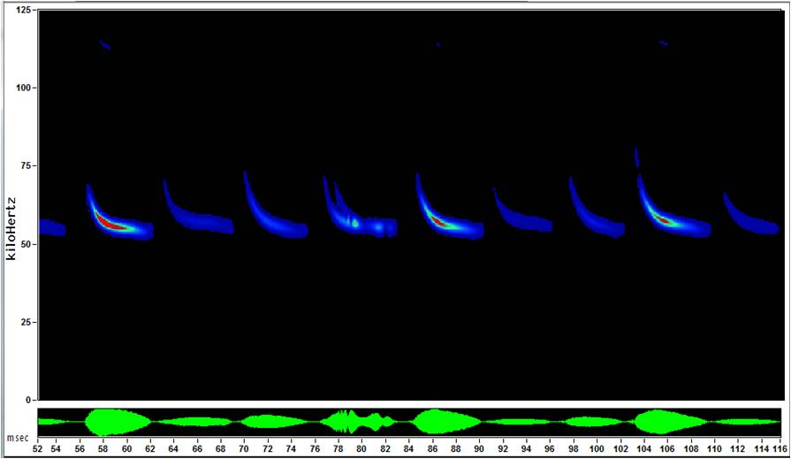
Dr Stuart Newson
BTO
The Nunnery
Thetford
Norfolk
IP24 2PU
Email: norfolkbatsurvey@gmail.com
For more information on the above species and other species of bats found in the UK see http://www.bats.org.uk/pages/uk_bats.html

Full recordings
^{Filename} | ^{time} | ^{species} | ^{os_grid} | ^{recording_night} | ^{month}
SURVEYTM0278_20150606_213250.wav | ^{21:32:50} | ^{Soprano pipistrelle} | ^{TM0278} | ⁶ | ^{June}
SURVEYTM0278_20150606_213349.wav | ^{21:33:49} | ^{Soprano pipistrelle} | ^{TM0278} | ⁶ | ^{June}
SURVEYTM0278_20150606_213606.wav | ^{21:36:06} | ^{Soprano pipistrelle} | ^{TM0278} | ⁶ | ^{June}
SURVEYTM0278_20150606_213629.wav | ^{21:36:29} | ^{Soprano pipistrelle} | ^{TM0278} | ⁶ | ^{June}
SURVEYTM0278_20150606_213713.wav | ^{21:37:13} | ^{Soprano pipistrelle} | ^{TM0278} | ⁶ | ^{June}
SURVEYTM0278_20150606_213740.wav | ^{21:37:40} | ^{Common pipistrelle} | ^{TM0278} | ⁶ | ^{June}
SURVEYTM0278_20150606_213748.wav | ^{21:37:48} | ^{Soprano pipistrelle} | ^{TM0278} | ⁶ | ^{June}
SURVEYTM0278_20150606_213757.wav | ^{21:37:57} | ^{Soprano pipistrelle} | ^{TM0278} | ⁶ | ^{June}
SURVEYTM0278_20150606_214020.wav | ^{21:40:20} | ^{Soprano pipistrelle} | ^{TM0278} | ⁶ | ^{June}
SURVEYTM0278_20150606_214332.wav | ^{21:43:32} | ^{Soprano pipistrelle} | ^{TM0278} | ⁶ | ^{June}
SURVEYTM0278_20150606_214351.wav | ^{21:43:51} | ^{Soprano pipistrelle} | ^{TM0278} | ⁶ | ^{June}
SURVEYTM0278_20150606_214403.wav | ^{21:44:03} | ^{Pipistrelle species} | ^{TM0278} | ⁶ | ^{June}
SURVEYTM0278_20150606_214628.wav | ^{21:46:28} | ^{Pipistrelle species} | ^{TM0278} | ⁶ | ^{June}
SURVEYTM0278_20150606_214642.wav | ^{21:46:42} | ^{Soprano pipistrelle} | ^{TM0278} | ⁶ | ^{June}
SURVEYTM0278_20150606_214917.wav | ^{21:49:17} | ^{Soprano pipistrelle} | ^{TM0278} | ⁶ | ^{June}
SURVEYTM0278_20150606_214929.wav | ^{21:49:29} | ^{Soprano pipistrelle} | ^{TM0278} | ⁶ | ^{June}
SURVEYTM0278_20150606_214944.wav | ^{21:49:44} | ^{Soprano pipistrelle} | ^{TM0278} | ⁶ | ^{June}
SURVEYTM0278_20150606_214958.wav | ^{21:49:58} | ^{Leisler’s} | ^{TM0278} | ⁶ | ^{June}
SURVEYTM0278_20150606_215008.wav | ^{21:50:08} | ^{Soprano pipistrelle} | ^{TM0278} | ⁶ | ^{June}
SURVEYTM0278_20150606_215019.wav | ^{21:50:19} | ^{Myotis species} | ^{TM0278} | ⁶ | ^{June}
SURVEYTM0278_20150606_215037.wav | ^{21:50:37} | ^{Soprano pipistrelle} | ^{TM0278} | ⁶ | ^{June}
SURVEYTM0278_20150606_215053.wav | ^{21:50:53} | ^{Common pipistrelle} | ^{TM0278} | ⁶ | ^{June}
SURVEYTM0278_20150606_215108.wav | ^{21:51:08} | ^{Pipistrelle species} | ^{TM0278} | ⁶ | ^{June}
SURVEYTM0278_20150606_215137.wav | ^{21:51:37} | ^{Soprano pipistrelle} | ^{TM0278} | ⁶ | ^{June}
SURVEYTM0278_20150606_215148.wav | ^{21:51:48} | ^{Pipistrelle species} | ^{TM0278} | ⁶ | ^{June}
SURVEYTM0278_20150606_215205.wav | ^{21:52:05} | ^{Soprano pipistrelle} | ^{TM0278} | ⁶ | ^{June}
SURVEYTM0278_20150606_215218.wav | ^{21:52:18} | ^{Soprano pipistrelle} | ^{TM0278} | ⁶ | ^{June}
SURVEYTM0278_20150606_215249.wav | ^{21:52:49} | ^{Soprano pipistrelle} | ^{TM0278} | ⁶ | ^{June}
SURVEYTM0278_20150606_215259.wav | ^{21:52:59} | ^{Soprano pipistrelle} | ^{TM0278} | ⁶ | ^{June}
SURVEYTM0278_20150606_215313.wav | ^{21:53:13} | ^{Soprano pipistrelle} | ^{TM0278} | ⁶ | ^{June}
SURVEYTM0278_20150606_215324.wav | ^{21:53:24} | ^{Soprano pipistrelle} | ^{TM0278} | ⁶ | ^{June}
SURVEYTM0278_20150606_215344.wav | ^{21:53:44} | ^{Soprano pipistrelle} | ^{TM0278} | ⁶ | ^{June}
SURVEYTM0278_20150606_215354.wav | ^{21:53:54} | ^{Soprano pipistrelle} | ^{TM0278} | ⁶ | ^{June}
SURVEYTM0278_20150606_215401.wav | ^{21:54:01} | ^{Myotis species} | ^{TM0278} | ⁶ | ^{June}
SURVEYTM0278_20150606_215418.wav | ^{21:54:18} | ^{Soprano pipistrelle} | ^{TM0278} | ⁶ | ^{June}
SURVEYTM0278_20150606_215428.wav | ^{21:54:28} | ^{Soprano pipistrelle} | ^{TM0278} | ⁶ | ^{June}
SURVEYTM0278_20150606_215443.wav | ^{21:54:43} | ^{Pipistrelle species} | ^{TM0278} | ⁶ | ^{June}
SURVEYTM0278_20150606_215449.wav | ^{21:54:49} | ^{Soprano pipistrelle} | ^{TM0278} | ⁶ | ^{June}
SURVEYTM0278_20150606_215502.wav | ^{21:55:02} | ^{Myotis species} | ^{TM0278} | ⁶ | ^{June}
SURVEYTM0278_20150606_215521.wav | ^{21:55:21} | ^{Soprano pipistrelle} | ^{TM0278} | ⁶ | ^{June}
SURVEYTM0278_20150606_215533.wav | ^{21:55:33} | ^{Soprano pipistrelle} | ^{TM0278} | ⁶ | ^{June}
SURVEYTM0278_20150606_215559.wav | ^{21:55:59} | ^{Soprano pipistrelle} | ^{TM0278} | ⁶ | ^{June}
SURVEYTM0278_20150606_215605.wav | ^{21:56:05} | ^{Common pipistrelle} | ^{TM0278} | ⁶ | ^{June}
SURVEYTM0278_20150606_215618.wav | ^{21:56:18} | ^{Pipistrelle species} | ^{TM0278} | ⁶ | ^{June}
SURVEYTM0278_20150606_215635.wav | ^{21:56:35} | ^{Myotis species} | ^{TM0278} | ⁶ | ^{June}
SURVEYTM0278_20150606_215702.wav | ^{21:57:02} | ^{Myotis species} | ^{TM0278} | ⁶ | ^{June}
SURVEYTM0278_20150606_215716.wav | ^{21:57:16} | ^{Common pipistrelle} | ^{TM0278} | ⁶ | ^{June}
SURVEYTM0278_20150606_215721.wav | ^{21:57:21} | ^{Myotis species} | ^{TM0278} | ⁶ | ^{June}
SURVEYTM0278_20150606_215728.wav | ^{21:57:28} | ^{Soprano pipistrelle} | ^{TM0278} | ⁶ | ^{June}
SURVEYTM0278_20150606_215747.wav | ^{21:57:47} | ^{Soprano pipistrelle} | ^{TM0278} | ⁶ | ^{June}
SURVEYTM0278_20150606_215817.wav | ^{21:58:17} | ^{Soprano pipistrelle} | ^{TM0278} | ⁶ | ^{June}
SURVEYTM0278_20150606_215933.wav | ^{21:59:33} | ^{Soprano pipistrelle} | ^{TM0278} | ⁶ | ^{June}
SURVEYTM0278_20150606_220005.wav | ^{22:00:05} | ^{Pipistrelle species} | ^{TM0278} | ⁶ | ^{June}
SURVEYTM0278_20150606_220012.wav | ^{22:00:12} | ^{Soprano pipistrelle} | ^{TM0278} | ⁶ | ^{June}
SURVEYTM0278_20150606_220102.wav | ^{22:01:02} | ^{Pipistrelle species} | ^{TM0278} | ⁶ | ^{June}
SURVEYTM0278_20150606_220117.wav | ^{22:01:17} | ^{Soprano pipistrelle} | ^{TM0278} | ⁶ | ^{June}
SURVEYTM0278_20150606_220133.wav | ^{22:01:33} | ^{Pipistrelle species} | ^{TM0278} | ⁶ | ^{June}
SURVEYTM0278_20150606_220208.wav | ^{22:02:08} | ^{Pipistrelle species} | ^{TM0278} | ⁶ | ^{June}
SURVEYTM0278_20150606_220224.wav | ^{22:02:24} | ^{Soprano pipistrelle} | ^{TM0278} | ⁶ | ^{June}
SURVEYTM0278_20150606_220317.wav | ^{22:03:17} | ^{Soprano pipistrelle} | ^{TM0278} | ⁶ | ^{June}
SURVEYTM0278_20150606_220342.wav | ^{22:03:42} | ^{Soprano pipistrelle} | ^{TM0278} | ⁶ | ^{June}
SURVEYTM0278_20150606_220352.wav | ^{22:03:52} | ^{Soprano pipistrelle} | ^{TM0278} | ⁶ | ^{June}
SURVEYTM0278_20150606_220403.wav | ^{22:04:03} | ^{Pipistrelle species} | ^{TM0278} | ⁶ | ^{June}
SURVEYTM0278_20150606_220415.wav | ^{22:04:15} | ^{Soprano pipistrelle} | ^{TM0278} | ⁶ | ^{June}
SURVEYTM0278_20150606_220430.wav | ^{22:04:30} | ^{Soprano pipistrelle} | ^{TM0278} | ⁶ | ^{June}
SURVEYTM0278_20150606_220531.wav | ^{22:05:31} | ^{Soprano pipistrelle} | ^{TM0278} | ⁶ | ^{June}
SURVEYTM0278_20150606_220549.wav | ^{22:05:49} | ^{Soprano pipistrelle} | ^{TM0278} | ⁶ | ^{June}
SURVEYTM0278_20150606_220602.wav | ^{22:06:02} | ^{Soprano pipistrelle} | ^{TM0278} | ⁶ | ^{June}
SURVEYTM0278_20150606_220613.wav | ^{22:06:13} | ^{Soprano pipistrelle} | ^{TM0278} | ⁶ | ^{June}
SURVEYTM0278_20150606_220627.wav | ^{22:06:27} | ^{Pipistrelle species} | ^{TM0278} | ⁶ | ^{June}
SURVEYTM0278_20150606_220650.wav | ^{22:06:50} | ^{Soprano pipistrelle} | ^{TM0278} | ⁶ | ^{June}
SURVEYTM0278_20150606_220700.wav | ^{22:07:00} | ^{Soprano pipistrelle} | ^{TM0278} | ⁶ | ^{June}
SURVEYTM0278_20150606_220711.wav | ^{22:07:11} | ^{Soprano pipistrelle} | ^{TM0278} | ⁶ | ^{June}
SURVEYTM0278_20150606_220717.wav | ^{22:07:17} | ^{Soprano pipistrelle} | ^{TM0278} | ⁶ | ^{June}
SURVEYTM0278_20150606_220727.wav | ^{22:07:27} | ^{Soprano pipistrelle} | ^{TM0278} | ⁶ | ^{June}
SURVEYTM0278_20150606_220734.wav | ^{22:07:34} | ^{Soprano pipistrelle} | ^{TM0278} | ⁶ | ^{June}
SURVEYTM0278_20150606_220813.wav | ^{22:08:13} | ^{Pipistrelle species} | ^{TM0278} | ⁶ | ^{June}
SURVEYTM0278_20150606_220828.wav | ^{22:08:28} | ^{Soprano pipistrelle} | ^{TM0278} | ⁶ | ^{June}
SURVEYTM0278_20150606_220854.wav | ^{22:08:54} | ^{Soprano pipistrelle} | ^{TM0278} | ⁶ | ^{June}
SURVEYTM0278_20150606_220900.wav | ^{22:09:00} | ^{Soprano pipistrelle} | ^{TM0278} | ⁶ | ^{June}
SURVEYTM0278_20150606_220909.wav | ^{22:09:09} | ^{Soprano pipistrelle} | ^{TM0278} | ⁶ | ^{June}
SURVEYTM0278_20150606_220922.wav | ^{22:09:22} | ^{Pipistrelle species} | ^{TM0278} | ⁶ | ^{June}
SURVEYTM0278_20150606_220932.wav | ^{22:09:32} | ^{Common pipistrelle} | ^{TM0278} | ⁶ | ^{June}
SURVEYTM0278_20150606_220941.wav | ^{22:09:41} | ^{Pipistrelle species} | ^{TM0278} | ⁶ | ^{June}
SURVEYTM0278_20150606_221047.wav | ^{22:10:47} | ^{Soprano pipistrelle} | ^{TM0278} | ⁶ | ^{June}
SURVEYTM0278_20150606_221147.wav | ^{22:11:47} | ^{Soprano pipistrelle} | ^{TM0278} | ⁶ | ^{June}
SURVEYTM0278_20150606_221253.wav | ^{22:12:53} | ^{Soprano pipistrelle} | ^{TM0278} | ⁶ | ^{June}
SURVEYTM0278_20150606_221258.wav | ^{22:12:58} | ^{Pipistrelle species} | ^{TM0278} | ⁶ | ^{June}
SURVEYTM0278_20150606_221310.wav | ^{22:13:10} | ^{Pipistrelle species} | ^{TM0278} | ⁶ | ^{June}
SURVEYTM0278_20150606_221321.wav | ^{22:13:21} | ^{Soprano pipistrelle} | ^{TM0278} | ⁶ | ^{June}
SURVEYTM0278_20150606_221326.wav | ^{22:13:26} | ^{Soprano pipistrelle} | ^{TM0278} | ⁶ | ^{June}
SURVEYTM0278_20150606_221337.wav | ^{22:13:37} | ^{Pipistrelle species} | ^{TM0278} | ⁶ | ^{June}
SURVEYTM0278_20150606_221418.wav | ^{22:14:18} | ^{Soprano pipistrelle} | ^{TM0278} | ⁶ | ^{June}
SURVEYTM0278_20150606_221429.wav | ^{22:14:29} | ^{Soprano pipistrelle} | ^{TM0278} | ⁶ | ^{June}
SURVEYTM0278_20150606_221439.wav | ^{22:14:39} | ^{Soprano pipistrelle} | ^{TM0278} | ⁶ | ^{June}
SURVEYTM0278_20150606_221451.wav | ^{22:14:51} | ^{Soprano pipistrelle} | ^{TM0278} | ⁶ | ^{June}
SURVEYTM0278_20150606_221501.wav | ^{22:15:01} | ^{Soprano pipistrelle} | ^{TM0278} | ⁶ | ^{June}
SURVEYTM0278_20150606_221535.wav | ^{22:15:35} | ^{Common pipistrelle} | ^{TM0278} | ⁶ | ^{June}
SURVEYTM0278_20150606_221542.wav | ^{22:15:42} | ^{Pipistrelle species} | ^{TM0278} | ⁶ | ^{June}
SURVEYTM0278_20150606_221559.wav | ^{22:15:59} | ^{Soprano pipistrelle} | ^{TM0278} | ⁶ | ^{June}
SURVEYTM0278_20150606_221735.wav | ^{22:17:35} | ^{Soprano pipistrelle} | ^{TM0278} | ⁶ | ^{June}
SURVEYTM0278_20150606_221831.wav | ^{22:18:31} | ^{Soprano pipistrelle} | ^{TM0278} | ⁶ | ^{June}
SURVEYTM0278_20150606_221952.wav | ^{22:19:52} | ^{Common pipistrelle} | ^{TM0278} | ⁶ | ^{June}
SURVEYTM0278_20150606_222123.wav | ^{22:21:23} | ^{Soprano pipistrelle} | ^{TM0278} | ⁶ | ^{June}
SURVEYTM0278_20150606_222146.wav | ^{22:21:46} | ^{Pipistrelle species} | ^{TM0278} | ⁶ | ^{June}
SURVEYTM0278_20150606_222221.wav | ^{22:22:21} | ^{Soprano pipistrelle} | ^{TM0278} | ⁶ | ^{June}
SURVEYTM0278_20150606_222237.wav | ^{22:22:37} | ^{Soprano pipistrelle} | ^{TM0278} | ⁶ | ^{June}
SURVEYTM0278_20150606_222318.wav | ^{22:23:18} | ^{Common pipistrelle} | ^{TM0278} | ⁶ | ^{June}
SURVEYTM0278_20150606_222333.wav | ^{22:23:33} | ^{Soprano pipistrelle} | ^{TM0278} | ⁶ | ^{June}
SURVEYTM0278_20150606_222344.wav | ^{22:23:44} | ^{Soprano pipistrelle} | ^{TM0278} | ⁶ | ^{June}
SURVEYTM0278_20150606_222422.wav | ^{22:24:22} | ^{Common pipistrelle} | ^{TM0278} | ⁶ | ^{June}
SURVEYTM0278_20150606_222426.wav | ^{22:24:26} | ^{Common pipistrelle} | ^{TM0278} | ⁶ | ^{June}
SURVEYTM0278_20150606_222436.wav | ^{22:24:36} | ^{Common pipistrelle} | ^{TM0278} | ⁶ | ^{June}
SURVEYTM0278_20150606_222620.wav | ^{22:26:20} | ^{Soprano pipistrelle} | ^{TM0278} | ⁶ | ^{June}
SURVEYTM0278_20150606_222647.wav | ^{22:26:47} | ^{Soprano pipistrelle} | ^{TM0278} | ⁶ | ^{June}
SURVEYTM0278_20150606_222702.wav | ^{22:27:02} | ^{Pipistrelle species} | ^{TM0278} | ⁶ | ^{June}
SURVEYTM0278_20150606_222806.wav | ^{22:28:06} | ^{Soprano pipistrelle} | ^{TM0278} | ⁶ | ^{June}
SURVEYTM0278_20150606_222823.wav | ^{22:28:23} | ^{Soprano pipistrelle} | ^{TM0278} | ⁶ | ^{June}
SURVEYTM0278_20150606_222830.wav | ^{22:28:30} | ^{Soprano pipistrelle} | ^{TM0278} | ⁶ | ^{June}
SURVEYTM0278_20150606_222837.wav | ^{22:28:37} | ^{Soprano pipistrelle} | ^{TM0278} | ⁶ | ^{June}
SURVEYTM0278_20150606_222930.wav | ^{22:29:30} | ^{Common pipistrelle} | ^{TM0278} | ⁶ | ^{June}
SURVEYTM0278_20150606_223101.wav | ^{22:31:01} | ^{Common pipistrelle} | ^{TM0278} | ⁶ | ^{June}
SURVEYTM0278_20150606_223118.wav | ^{22:31:18} | ^{Common pipistrelle} | ^{TM0278} | ⁶ | ^{June}
SURVEYTM0278_20150606_223152.wav | ^{22:31:52} | ^{Soprano pipistrelle} | ^{TM0278} | ⁶ | ^{June}
SURVEYTM0278_20150606_223240.wav | ^{22:32:40} | ^{Soprano pipistrelle} | ^{TM0278} | ⁶ | ^{June}
SURVEYTM0278_20150606_223355.wav | ^{22:33:55} | ^{Pipistrelle species} | ^{TM0278} | ⁶ | ^{June}
SURVEYTM0278_20150606_223624.wav | ^{22:36:24} | ^{Soprano pipistrelle} | ^{TM0278} | ⁶ | ^{June}
SURVEYTM0278_20150606_223631.wav | ^{22:36:31} | ^{Noctule} | ^{TM0278} | ⁶ | ^{June}
SURVEYTM0278_20150606_223636.wav | ^{22:36:36} | ^{Noctule} | ^{TM0278} | ⁶ | ^{June}
SURVEYTM0278_20150606_223649.wav | ^{22:36:49} | ^{Common pipistrelle} | ^{TM0278} | ⁶ | ^{June}
SURVEYTM0278_20150606_223702.wav | ^{22:37:02} | ^{Soprano pipistrelle} | ^{TM0278} | ⁶ | ^{June}
SURVEYTM0278_20150606_223755.wav | ^{22:37:55} | ^{Soprano pipistrelle} | ^{TM0278} | ⁶ | ^{June}
SURVEYTM0278_20150606_224301.wav | ^{22:43:01} | ^{Common pipistrelle} | ^{TM0278} | ⁶ | ^{June}
SURVEYTM0278_20150606_224412.wav | ^{22:44:12} | ^{Common pipistrelle} | ^{TM0278} | ⁶ | ^{June}
SURVEYTM0278_20150606_224505.wav | ^{22:45:05} | ^{Common pipistrelle} | ^{TM0278} | ⁶ | ^{June}
SURVEYTM0278_20150606_224657.wav | ^{22:46:57} | ^{Common pipistrelle} | ^{TM0278} | ⁶ | ^{June}
SURVEYTM0278_20150606_224711.wav | ^{22:47:11} | ^{Common pipistrelle} | ^{TM0278} | ⁶ | ^{June}
SURVEYTM0278_20150606_224721.wav | ^{22:47:21} | ^{Common pipistrelle} | ^{TM0278} | ⁶ | ^{June}
SURVEYTM0278_20150606_224801.wav | ^{22:48:01} | ^{Common pipistrelle} | ^{TM0278} | ⁶ | ^{June}
SURVEYTM0278_20150606_225004.wav | ^{22:50:04} | ^{Soprano pipistrelle} | ^{TM0278} | ⁶ | ^{June}
SURVEYTM0278_20150606_225117.wav | ^{22:51:17} | ^{Common pipistrelle} | ^{TM0278} | ⁶ | ^{June}
SURVEYTM0278_20150606_225248.wav | ^{22:52:48} | ^{Soprano pipistrelle} | ^{TM0278} | ⁶ | ^{June}
SURVEYTM0278_20150606_225255.wav | ^{22:52:55} | ^{Common pipistrelle} | ^{TM0278} | ⁶ | ^{June}
SURVEYTM0278_20150606_225307.wav | ^{22:53:07} | ^{Common pipistrelle} | ^{TM0278} | ⁶ | ^{June}
SURVEYTM0278_20150606_225346.wav | ^{22:53:46} | ^{Soprano pipistrelle} | ^{TM0278} | ⁶ | ^{June}
SURVEYTM0278_20150606_225626.wav | ^{22:56:26} | ^{Soprano pipistrelle} | ^{TM0278} | ⁶ | ^{June}
SURVEYTM0278_20150606_225640.wav | ^{22:56:40} | ^{Pipistrelle species} | ^{TM0278} | ⁶ | ^{June}
SURVEYTM0278_20150606_225825.wav | ^{22:58:25} | ^{Common pipistrelle} | ^{TM0278} | ⁶ | ^{June}
SURVEYTM0278_20150606_230014.wav | ^{23:00:14} | ^{Common pipistrelle} | ^{TM0278} | ⁶ | ^{June}
SURVEYTM0278_20150606_230108.wav | ^{23:01:08} | ^{Common pipistrelle} | ^{TM0278} | ⁶ | ^{June}
SURVEYTM0278_20150606_230118.wav | ^{23:01:18} | ^{Soprano pipistrelle} | ^{TM0278} | ⁶ | ^{June}
SURVEYTM0278_20150606_230136.wav | ^{23:01:36} | ^{Soprano pipistrelle} | ^{TM0278} | ⁶ | ^{June}
SURVEYTM0278_20150606_230207.wav | ^{23:02:07} | ^{Soprano pipistrelle} | ^{TM0278} | ⁶ | ^{June}
SURVEYTM0278_20150606_230228.wav | ^{23:02:28} | ^{Soprano pipistrelle} | ^{TM0278} | ⁶ | ^{June}
SURVEYTM0278_20150606_230247.wav | ^{23:02:47} | ^{Common pipistrelle} | ^{TM0278} | ⁶ | ^{June}
SURVEYTM0278_20150606_230258.wav | ^{23:02:58} | ^{Common pipistrelle} | ^{TM0278} | ⁶ | ^{June}
SURVEYTM0278_20150606_230310.wav | ^{23:03:10} | ^{Soprano pipistrelle} | ^{TM0278} | ⁶ | ^{June}
SURVEYTM0278_20150606_230408.wav | ^{23:04:08} | ^{Common pipistrelle} | ^{TM0278} | ⁶ | ^{June}
SURVEYTM0278_20150606_230427.wav | ^{23:04:27} | ^{Common pipistrelle} | ^{TM0278} | ⁶ | ^{June}
SURVEYTM0278_20150606_230445.wav | ^{23:04:45} | ^{Soprano pipistrelle} | ^{TM0278} | ⁶ | ^{June}
SURVEYTM0278_20150606_230512.wav | ^{23:05:12} | ^{Soprano pipistrelle} | ^{TM0278} | ⁶ | ^{June}
SURVEYTM0278_20150606_230527.wav | ^{23:05:27} | ^{Common pipistrelle} | ^{TM0278} | ⁶ | ^{June}
SURVEYTM0278_20150606_230604.wav | ^{23:06:04} | ^{Common pipistrelle} | ^{TM0278} | ⁶ | ^{June}
SURVEYTM0278_20150606_230616.wav | ^{23:06:16} | ^{Common pipistrelle} | ^{TM0278} | ⁶ | ^{June}
SURVEYTM0278_20150606_230707.wav | ^{23:07:07} | ^{Soprano pipistrelle} | ^{TM0278} | ⁶ | ^{June}
SURVEYTM0278_20150606_231153.wav | ^{23:11:53} | ^{Soprano pipistrelle} | ^{TM0278} | ⁶ | ^{June}
SURVEYTM0278_20150606_231236.wav | ^{23:12:36} | ^{Soprano pipistrelle} | ^{TM0278} | ⁶ | ^{June}
SURVEYTM0278_20150606_231249.wav | ^{23:12:49} | ^{Common pipistrelle} | ^{TM0278} | ⁶ | ^{June}
SURVEYTM0278_20150606_231522.wav | ^{23:15:22} | ^{Soprano pipistrelle} | ^{TM0278} | ⁶ | ^{June}
SURVEYTM0278_20150606_231556.wav | ^{23:15:56} | ^{Soprano pipistrelle} | ^{TM0278} | ⁶ | ^{June}
SURVEYTM0278_20150606_231751.wav | ^{23:17:51} | ^{Soprano pipistrelle} | ^{TM0278} | ⁶ | ^{June}
SURVEYTM0278_20150606_231854.wav | ^{23:18:54} | ^{Soprano pipistrelle} | ^{TM0278} | ⁶ | ^{June}
SURVEYTM0278_20150606_232148.wav | ^{23:21:48} | ^{Common pipistrelle} | ^{TM0278} | ⁶ | ^{June}
SURVEYTM0278_20150606_232614.wav | ^{23:26:14} | ^{Soprano pipistrelle} | ^{TM0278} | ⁶ | ^{June}
SURVEYTM0278_20150606_232805.wav | ^{23:28:05} | ^{Soprano pipistrelle} | ^{TM0278} | ⁶ | ^{June}
SURVEYTM0278_20150606_233006.wav | ^{23:30:06} | ^{Soprano pipistrelle} | ^{TM0278} | ⁶ | ^{June}
SURVEYTM0278_20150606_233244.wav | ^{23:32:44} | ^{Soprano pipistrelle} | ^{TM0278} | ⁶ | ^{June}
SURVEYTM0278_20150606_233452.wav | ^{23:34:52} | ^{Soprano pipistrelle} | ^{TM0278} | ⁶ | ^{June}
SURVEYTM0278_20150606_233508.wav | ^{23:35:08} | ^{Soprano pipistrelle} | ^{TM0278} | ⁶ | ^{June}
SURVEYTM0278_20150606_233615.wav | ^{23:36:15} | ^{Soprano pipistrelle} | ^{TM0278} | ⁶ | ^{June}
SURVEYTM0278_20150606_233823.wav | ^{23:38:23} | ^{Soprano pipistrelle} | ^{TM0278} | ⁶ | ^{June}
SURVEYTM0278_20150606_233852.wav | ^{23:38:52} | ^{Soprano pipistrelle} | ^{TM0278} | ⁶ | ^{June}
SURVEYTM0278_20150606_233857.wav | ^{23:38:57} | ^{Common pipistrelle} | ^{TM0278} | ⁶ | ^{June}
SURVEYTM0278_20150606_233917.wav | ^{23:39:17} | ^{Soprano pipistrelle} | ^{TM0278} | ⁶ | ^{June}
SURVEYTM0278_20150606_233939.wav | ^{23:39:39} | ^{Brown long-eared bat} | ^{TM0278} | ⁶ | ^{June}
SURVEYTM0278_20150606_234119.wav | ^{23:41:19} | ^{Soprano pipistrelle} | ^{TM0278} | ⁶ | ^{June}
SURVEYTM0278_20150606_234124.wav | ^{23:41:24} | ^{Common pipistrelle} | ^{TM0278} | ⁶ | ^{June}
SURVEYTM0278_20150606_234207.wav | ^{23:42:07} | ^{Soprano pipistrelle} | ^{TM0278} | ⁶ | ^{June}
SURVEYTM0278_20150606_234413.wav | ^{23:44:13} | ^{Common pipistrelle} | ^{TM0278} | ⁶ | ^{June}
SURVEYTM0278_20150606_234725.wav | ^{23:47:25} | ^{Soprano pipistrelle} | ^{TM0278} | ⁶ | ^{June}
SURVEYTM0278_20150606_235324.wav | ^{23:53:24} | ^{Common pipistrelle} | ^{TM0278} | ⁶ | ^{June}
SURVEYTM0278_20150606_235408.wav | ^{23:54:08} | ^{Myotis species} | ^{TM0278} | ⁶ | ^{June}
SURVEYTM0278_20150607_000221.wav | ^{00:02:21} | ^{Soprano pipistrelle} | ^{TM0278} | ⁶ | ^{June}
SURVEYTM0278_20150607_000328.wav | ^{00:03:28} | ^{Brown long-eared bat} | ^{TM0278} | ⁶ | ^{June}
SURVEYTM0278_20150607_000412.wav | ^{00:04:12} | ^{Soprano pipistrelle} | ^{TM0278} | ⁶ | ^{June}
SURVEYTM0278_20150607_000453.wav | ^{00:04:53} | ^{Common pipistrelle} | ^{TM0278} | ⁶ | ^{June}
SURVEYTM0278_20150607_000655.wav | ^{00:06:55} | ^{Soprano pipistrelle} | ^{TM0278} | ⁶ | ^{June}
SURVEYTM0278_20150607_000713.wav | ^{00:07:13} | ^{Soprano pipistrelle} | ^{TM0278} | ⁶ | ^{June}
SURVEYTM0278_20150607_000720.wav | ^{00:07:20} | ^{Soprano pipistrelle} | ^{TM0278} | ⁶ | ^{June}
SURVEYTM0278_20150607_000840.wav | ^{00:08:40} | ^{Common pipistrelle} | ^{TM0278} | ⁶ | ^{June}
SURVEYTM0278_20150607_001050.wav | ^{00:10:50} | ^{Soprano pipistrelle} | ^{TM0278} | ⁶ | ^{June}
SURVEYTM0278_20150607_001606.wav | ^{00:16:06} | ^{Myotis species} | ^{TM0278} | ⁶ | ^{June}
SURVEYTM0278_20150607_001702.wav | ^{00:17:02} | ^{Common pipistrelle} | ^{TM0278} | ⁶ | ^{June}
SURVEYTM0278_20150607_001757.wav | ^{00:17:57} | ^{Soprano pipistrelle} | ^{TM0278} | ⁶ | ^{June}
SURVEYTM0278_20150607_003218.wav | ^{00:32:18} | ^{Common pipistrelle} | ^{TM0278} | ⁶ | ^{June}
SURVEYTM0278_20150607_003444.wav | ^{00:34:44} | ^{Pipistrelle species} | ^{TM0278} | ⁶ | ^{June}
SURVEYTM0278_20150607_003452.wav | ^{00:34:52} | ^{Soprano pipistrelle} | ^{TM0278} | ⁶ | ^{June}
SURVEYTM0278_20150607_005945.wav | ^{00:59:45} | ^{Common pipistrelle} | ^{TM0278} | ⁶ | ^{June}
SURVEYTM0278_20150607_010102.wav | ^{01:01:02} | ^{Common pipistrelle} | ^{TM0278} | ⁶ | ^{June}
SURVEYTM0278_20150607_010430.wav | ^{01:04:30} | ^{Noctule Serotine or Leisler’s} | ^{TM0278} | ⁶ | ^{June}
SURVEYTM0278_20150607_011008.wav | ^{01:10:08} | ^{Soprano pipistrelle} | ^{TM0278} | ⁶ | ^{June}
SURVEYTM0278_20150607_011143.wav | ^{01:11:43} | Whiskered / Brandt’s - low confidence | ^{TM0278} | ⁶ | ^{June}
SURVEYTM0278_20150607_012048.wav | ^{01:20:48} | ^{Myotis species} | ^{TM0278} | ⁶ | ^{June}
SURVEYTM0278_20150607_012530.wav | ^{01:25:30} | ^{Myotis species} | ^{TM0278} | ⁶ | ^{June}
SURVEYTM0278_20150607_020744.wav | ^{02:07:44} | ^{Barbastelle} | ^{TM0278} | ⁶ | ^{June}
SURVEYTM0278_20150607_021232.wav | ^{02:12:32} | ^{Common pipistrelle} | ^{TM0278} | ⁶ | ^{June}
SURVEYTM0278_20150607_024317.wav | ^{02:43:17} | ^{Soprano pipistrelle} | ^{TM0278} | ⁶ | ^{June}
SURVEYTM0278_20150607_024858.wav | ^{02:48:58} | ^{Soprano pipistrelle} | ^{TM0278} | ⁶ | ^{June}
SURVEYTM0278_20150607_025631.wav | ^{02:56:31} | ^{Common pipistrelle} | ^{TM0278} | ⁶ | ^{June}
SURVEYTM0278_20150607_025937.wav | ^{02:59:37} | ^{Myotis species} | ^{TM0278} | ⁶ | ^{June}
SURVEYTM0278_20150607_030234.wav | ^{03:02:34} | ^{Leisler’s} | ^{TM0278} | ⁶ | ^{June}
SURVEYTM0278_20150607_030825.wav | ^{03:08:25} | ^{Common pipistrelle} | ^{TM0278} | ⁶ | ^{June}
SURVEYTM0278_20150607_031435.wav | ^{03:14:35} | ^{Common pipistrelle} | ^{TM0278} | ⁶ | ^{June}
SURVEYTM0278_20150607_032609.wav | ^{03:26:09} | ^{Common pipistrelle} | ^{TM0278} | ⁶ | ^{June}
SURVEYTM0278_20150607_033032.wav | ^{03:30:32} | ^{Soprano pipistrelle} | ^{TM0278} | ⁶ | ^{June}
SURVEYTM0278_20150607_033526.wav | ^{03:35:26} | ^{Common pipistrelle} | ^{TM0278} | ⁶ | ^{June}
SURVEYTM0278_20150607_033927.wav | ^{03:39:27} | ^{Common pipistrelle} | ^{TM0278} | ⁶ | ^{June}
SURVEYTM0278_20150617_213259.wav | ^{21:32:59} | ^{Soprano pipistrelle} | ^{TM0278} | ¹⁷ | ^{June}
SURVEYTM0278_20150617_213541.wav | ^{21:35:41} | ^{Soprano pipistrelle} | ^{TM0278} | ¹⁷ | ^{June}
SURVEYTM0278_20150617_213615.wav | ^{21:36:15} | ^{Soprano pipistrelle} | ^{TM0278} | ¹⁷ | ^{June}
SURVEYTM0278_20150617_213802.wav | ^{21:38:02} | ^{Soprano pipistrelle} | ^{TM0278} | ¹⁷ | ^{June}
SURVEYTM0278_20150617_213832.wav | ^{21:38:32} | ^{Soprano pipistrelle} | ^{TM0278} | ¹⁷ | ^{June}
SURVEYTM0278_20150617_213943.wav | ^{21:39:43} | ^{Common pipistrelle} | ^{TM0278} | ¹⁷ | ^{June}
SURVEYTM0278_20150617_214046.wav | ^{21:40:46} | ^{Common pipistrelle} | ^{TM0278} | ¹⁷ | ^{June}
SURVEYTM0278_20150617_214347.wav | ^{21:43:47} | ^{Soprano pipistrelle} | ^{TM0278} | ¹⁷ | ^{June}
SURVEYTM0278_20150617_214404.wav | ^{21:44:04} | ^{Soprano pipistrelle} | ^{TM0278} | ¹⁷ | ^{June}
SURVEYTM0278_20150617_214423.wav | ^{21:44:23} | ^{Soprano pipistrelle} | ^{TM0278} | ¹⁷ | ^{June}
SURVEYTM0278_20150617_214446.wav | ^{21:44:46} | ^{Soprano pipistrelle} | ^{TM0278} | ¹⁷ | ^{June}
SURVEYTM0278_20150617_214511.wav | ^{21:45:11} | ^{Pipistrelle species} | ^{TM0278} | ¹⁷ | ^{June}
SURVEYTM0278_20150617_214539.wav | ^{21:45:39} | ^{Soprano pipistrelle} | ^{TM0278} | ¹⁷ | ^{June}
SURVEYTM0278_20150617_214632.wav | ^{21:46:32} | ^{Leisler’s} | ^{TM0278} | ¹⁷ | ^{June}
SURVEYTM0278_20150617_214731.wav | ^{21:47:31} | ^{Soprano pipistrelle} | ^{TM0278} | ¹⁷ | ^{June}
SURVEYTM0278_20150617_215843.wav | ^{21:58:43} | ^{Soprano pipistrelle} | ^{TM0278} | ¹⁷ | ^{June}
SURVEYTM0278_20150617_220925.wav | ^{22:09:25} | ^{Common pipistrelle} | ^{TM0278} | ¹⁷ | ^{June}
SURVEYTM0278_20150617_221321.wav | ^{22:13:21} | ^{Myotis species} | ^{TM0278} | ¹⁷ | ^{June}
SURVEYTM0278_20150617_221816.wav | ^{22:18:16} | ^{Myotis species} | ^{TM0278} | ¹⁷ | ^{June}
SURVEYTM0278_20150617_222711.wav | ^{22:27:11} | ^{Myotis species} | ^{TM0278} | ¹⁷ | ^{June}
SURVEYTM0278_20150617_223632.wav | ^{22:36:32} | ^{Common pipistrelle} | ^{TM0278} | ¹⁷ | ^{June}
SURVEYTM0278_20150617_224227.wav | ^{22:42:27} | ^{Soprano pipistrelle} | ^{TM0278} | ¹⁷ | ^{June}
SURVEYTM0278_20150617_224649.wav | ^{22:46:49} | ^{Pipistrelle species} | ^{TM0278} | ¹⁷ | ^{June}
SURVEYTM0278_20150617_224658.wav | ^{22:46:58} | ^{Pipistrelle species} | ^{TM0278} | ¹⁷ | ^{June}
SURVEYTM0278_20150617_225046.wav | ^{22:50:46} | ^{Common pipistrelle} | ^{TM0278} | ¹⁷ | ^{June}
SURVEYTM0278_20150617_225300.wav | ^{22:53:00} | ^{Soprano pipistrelle} | ^{TM0278} | ¹⁷ | ^{June}
SURVEYTM0278_20150617_225418.wav | ^{22:54:18} | ^{Pipistrelle species} | ^{TM0278} | ¹⁷ | ^{June}
SURVEYTM0278_20150617_225911.wav | ^{22:59:11} | ^{Common pipistrelle} | ^{TM0278} | ¹⁷ | ^{June}
SURVEYTM0278_20150617_230157.wav | ^{23:01:57} | ^{Pipistrelle species} | ^{TM0278} | ¹⁷ | ^{June}
SURVEYTM0278_20150617_230328.wav | ^{23:03:28} | ^{Soprano pipistrelle} | ^{TM0278} | ¹⁷ | ^{June}
SURVEYTM0278_20150617_230531.wav | ^{23:05:31} | ^{Pipistrelle species} | ^{TM0278} | ¹⁷ | ^{June}
SURVEYTM0278_20150617_230543.wav | ^{23:05:43} | ^{Soprano pipistrelle} | ^{TM0278} | ¹⁷ | ^{June}
SURVEYTM0278_20150617_230552.wav | ^{23:05:52} | ^{Common pipistrelle} | ^{TM0278} | ¹⁷ | ^{June}
SURVEYTM0278_20150617_230836.wav | ^{23:08:36} | ^{Soprano pipistrelle} | ^{TM0278} | ¹⁷ | ^{June}
SURVEYTM0278_20150617_230920.wav | ^{23:09:20} | ^{Common pipistrelle} | ^{TM0278} | ¹⁷ | ^{June}
SURVEYTM0278_20150617_231029.wav | ^{23:10:29} | ^{Noctule} | ^{TM0278} | ¹⁷ | ^{June}
SURVEYTM0278_20150617_231035.wav | ^{23:10:35} | ^{Noctule} | ^{TM0278} | ¹⁷ | ^{June}
SURVEYTM0278_20150617_231821.wav | ^{23:18:21} | ^{Myotis species} | ^{TM0278} | ¹⁷ | ^{June}
SURVEYTM0278_20150617_232322.wav | ^{23:23:22} | ^{Common pipistrelle} | ^{TM0278} | ¹⁷ | ^{June}
SURVEYTM0278_20150617_232749.wav | ^{23:27:49} | ^{Common pipistrelle} | ^{TM0278} | ¹⁷ | ^{June}
SURVEYTM0278_20150617_233511.wav | ^{23:35:11} | ^{Soprano pipistrelle} | ^{TM0278} | ¹⁷ | ^{June}
SURVEYTM0278_20150617_234045.wav | ^{23:40:45} | ^{Soprano pipistrelle} | ^{TM0278} | ¹⁷ | ^{June}
SURVEYTM0278_20150617_234331.wav | ^{23:43:31} | ^{Common pipistrelle} | ^{TM0278} | ¹⁷ | ^{June}
SURVEYTM0278_20150617_234848.wav | ^{23:48:48} | ^{Soprano pipistrelle} | ^{TM0278} | ¹⁷ | ^{June}
SURVEYTM0278_20150617_235226.wav | ^{23:52:26} | ^{Soprano pipistrelle} | ^{TM0278} | ¹⁷ | ^{June}
SURVEYTM0278_20150617_235251.wav | ^{23:52:51} | ^{Soprano pipistrelle} | ^{TM0278} | ¹⁷ | ^{June}
SURVEYTM0278_20150617_235314.wav | ^{23:53:14} | ^{Soprano pipistrelle} | ^{TM0278} | ¹⁷ | ^{June}
SURVEYTM0278_20150617_235326.wav | ^{23:53:26} | ^{Myotis species} | ^{TM0278} | ¹⁷ | ^{June}
SURVEYTM0278_20150617_235532.wav | ^{23:55:32} | ^{Common pipistrelle} | ^{TM0278} | ¹⁷ | ^{June}
SURVEYTM0278_20150617_235543.wav | ^{23:55:43} | ^{Common pipistrelle} | ^{TM0278} | ¹⁷ | ^{June}
SURVEYTM0278_20150617_235608.wav | ^{23:56:08} | ^{Soprano pipistrelle} | ^{TM0278} | ¹⁷ | ^{June}
SURVEYTM0278_20150617_235614.wav | ^{23:56:14} | ^{Common pipistrelle} | ^{TM0278} | ¹⁷ | ^{June}
SURVEYTM0278_20150617_235626.wav | ^{23:56:26} | ^{Soprano pipistrelle} | ^{TM0278} | ¹⁷ | ^{June}
SURVEYTM0278_20150617_235752.wav | ^{23:57:52} | ^{Soprano pipistrelle} | ^{TM0278} | ¹⁷ | ^{June}
SURVEYTM0278_20150617_235813.wav | ^{23:58:13} | ^{Soprano pipistrelle} | ^{TM0278} | ¹⁷ | ^{June}
SURVEYTM0278_20150617_235951.wav | ^{23:59:51} | ^{Soprano pipistrelle} | ^{TM0278} | ¹⁷ | ^{June}
SURVEYTM0278_20150618_000026.wav | ^{00:00:26} | ^{Soprano pipistrelle} | ^{TM0278} | ¹⁷ | ^{June}
SURVEYTM0278_20150618_000051.wav | ^{00:00:51} | ^{Soprano pipistrelle} | ^{TM0278} | ¹⁷ | ^{June}
SURVEYTM0278_20150618_000145.wav | ^{00:01:45} | ^{Soprano pipistrelle} | ^{TM0278} | ¹⁷ | ^{June}
SURVEYTM0278_20150618_000203.wav | ^{00:02:03} | ^{Soprano pipistrelle} | ^{TM0278} | ¹⁷ | ^{June}
SURVEYTM0278_20150618_000239.wav | ^{00:02:39} | ^{Pipistrelle species} | ^{TM0278} | ¹⁷ | ^{June}
SURVEYTM0278_20150618_000305.wav | ^{00:03:05} | ^{Soprano pipistrelle} | ^{TM0278} | ¹⁷ | ^{June}
SURVEYTM0278_20150618_000325.wav | ^{00:03:25} | ^{Soprano pipistrelle} | ^{TM0278} | ¹⁷ | ^{June}
SURVEYTM0278_20150618_000341.wav | ^{00:03:41} | ^{Soprano pipistrelle} | ^{TM0278} | ¹⁷ | ^{June}
SURVEYTM0278_20150618_000415.wav | ^{00:04:15} | ^{Soprano pipistrelle} | ^{TM0278} | ¹⁷ | ^{June}
SURVEYTM0278_20150618_000438.wav | ^{00:04:38} | ^{Soprano pipistrelle} | ^{TM0278} | ¹⁷ | ^{June}
SURVEYTM0278_20150618_000504.wav | ^{00:05:04} | ^{Soprano pipistrelle} | ^{TM0278} | ¹⁷ | ^{June}
SURVEYTM0278_20150618_000525.wav | ^{00:05:25} | ^{Soprano pipistrelle} | ^{TM0278} | ¹⁷ | ^{June}
SURVEYTM0278_20150618_000537.wav | ^{00:05:37} | ^{Soprano pipistrelle} | ^{TM0278} | ¹⁷ | ^{June}
SURVEYTM0278_20150618_000554.wav | ^{00:05:54} | ^{Soprano pipistrelle} | ^{TM0278} | ¹⁷ | ^{June}
SURVEYTM0278_20150618_000607.wav | ^{00:06:07} | ^{Soprano pipistrelle} | ^{TM0278} | ¹⁷ | ^{June}
SURVEYTM0278_20150618_000621.wav | ^{00:06:21} | ^{Soprano pipistrelle} | ^{TM0278} | ¹⁷ | ^{June}
SURVEYTM0278_20150618_000638.wav | ^{00:06:38} | ^{Soprano pipistrelle} | ^{TM0278} | ¹⁷ | ^{June}
SURVEYTM0278_20150618_000652.wav | ^{00:06:52} | ^{Pipistrelle species} | ^{TM0278} | ¹⁷ | ^{June}
SURVEYTM0278_20150618_000707.wav | ^{00:07:07} | ^{Soprano pipistrelle} | ^{TM0278} | ¹⁷ | ^{June}
SURVEYTM0278_20150618_000740.wav | ^{00:07:40} | ^{Pipistrelle species} | ^{TM0278} | ¹⁷ | ^{June}
SURVEYTM0278_20150618_000750.wav | ^{00:07:50} | ^{Soprano pipistrelle} | ^{TM0278} | ¹⁷ | ^{June}
SURVEYTM0278_20150618_000801.wav | ^{00:08:01} | ^{Soprano pipistrelle} | ^{TM0278} | ¹⁷ | ^{June}
SURVEYTM0278_20150618_000813.wav | ^{00:08:13} | ^{Soprano pipistrelle} | ^{TM0278} | ¹⁷ | ^{June}
SURVEYTM0278_20150618_000834.wav | ^{00:08:34} | ^{Soprano pipistrelle} | ^{TM0278} | ¹⁷ | ^{June}
SURVEYTM0278_20150618_000854.wav | ^{00:08:54} | ^{Soprano pipistrelle} | ^{TM0278} | ¹⁷ | ^{June}
SURVEYTM0278_20150618_000923.wav | ^{00:09:23} | ^{Myotis species} | ^{TM0278} | ¹⁷ | ^{June}
SURVEYTM0278_20150618_000945.wav | ^{00:09:45} | ^{Soprano pipistrelle} | ^{TM0278} | ¹⁷ | ^{June}
SURVEYTM0278_20150618_000951.wav | ^{00:09:51} | ^{Soprano pipistrelle} | ^{TM0278} | ¹⁷ | ^{June}
SURVEYTM0278_20150618_000958.wav | ^{00:09:58} | ^{Soprano pipistrelle} | ^{TM0278} | ¹⁷ | ^{June}
SURVEYTM0278_20150618_001013.wav | ^{00:10:13} | ^{Soprano pipistrelle} | ^{TM0278} | ¹⁷ | ^{June}
SURVEYTM0278_20150618_001036.wav | ^{00:10:36} | ^{Myotis species} | ^{TM0278} | ¹⁷ | ^{June}
SURVEYTM0278_20150618_001106.wav | ^{00:11:06} | ^{Pipistrelle species} | ^{TM0278} | ¹⁷ | ^{June}
SURVEYTM0278_20150618_001200.wav | ^{00:12:00} | ^{Soprano pipistrelle} | ^{TM0278} | ¹⁷ | ^{June}
SURVEYTM0278_20150618_001221.wav | ^{00:12:21} | ^{Soprano pipistrelle} | ^{TM0278} | ¹⁷ | ^{June}
SURVEYTM0278_20150618_001259.wav | ^{00:12:59} | ^{Soprano pipistrelle} | ^{TM0278} | ¹⁷ | ^{June}
SURVEYTM0278_20150618_001306.wav | ^{00:13:06} | ^{Common pipistrelle} | ^{TM0278} | ¹⁷ | ^{June}
SURVEYTM0278_20150618_001325.wav | ^{00:13:25} | ^{Common pipistrelle} | ^{TM0278} | ¹⁷ | ^{June}
SURVEYTM0278_20150618_001337.wav | ^{00:13:37} | ^{Soprano pipistrelle} | ^{TM0278} | ¹⁷ | ^{June}
SURVEYTM0278_20150618_001352.wav | ^{00:13:52} | ^{Myotis species} | ^{TM0278} | ¹⁷ | ^{June}
SURVEYTM0278_20150618_001405.wav | ^{00:14:05} | ^{Common pipistrelle} | ^{TM0278} | ¹⁷ | ^{June}
SURVEYTM0278_20150618_001410.wav | ^{00:14:10} | ^{Common pipistrelle} | ^{TM0278} | ¹⁷ | ^{June}
SURVEYTM0278_20150618_001418.wav | ^{00:14:18} | ^{Soprano pipistrelle} | ^{TM0278} | ¹⁷ | ^{June}
SURVEYTM0278_20150618_001533.wav | ^{00:15:33} | ^{Soprano pipistrelle} | ^{TM0278} | ¹⁷ | ^{June}
SURVEYTM0278_20150618_001601.wav | ^{00:16:01} | ^{Pipistrelle species} | ^{TM0278} | ¹⁷ | ^{June}
SURVEYTM0278_20150618_001606.wav | ^{00:16:06} | ^{Soprano pipistrelle} | ^{TM0278} | ¹⁷ | ^{June}
SURVEYTM0278_20150618_001656.wav | ^{00:16:56} | ^{Soprano pipistrelle} | ^{TM0278} | ¹⁷ | ^{June}
SURVEYTM0278_20150618_001715.wav | ^{00:17:15} | ^{Soprano pipistrelle} | ^{TM0278} | ¹⁷ | ^{June}
SURVEYTM0278_20150618_001757.wav | ^{00:17:57} | ^{Soprano pipistrelle} | ^{TM0278} | ¹⁷ | ^{June}
SURVEYTM0278_20150618_001834.wav | ^{00:18:34} | ^{Soprano pipistrelle} | ^{TM0278} | ¹⁷ | ^{June}
SURVEYTM0278_20150618_001840.wav | ^{00:18:40} | ^{Soprano pipistrelle} | ^{TM0278} | ¹⁷ | ^{June}
SURVEYTM0278_20150618_001847.wav | ^{00:18:47} | ^{Soprano pipistrelle} | ^{TM0278} | ¹⁷ | ^{June}
SURVEYTM0278_20150618_001919.wav | ^{00:19:19} | ^{Common pipistrelle} | ^{TM0278} | ¹⁷ | ^{June}
SURVEYTM0278_20150618_001949.wav | ^{00:19:49} | ^{Common pipistrelle} | ^{TM0278} | ¹⁷ | ^{June}
SURVEYTM0278_20150618_002033.wav | ^{00:20:33} | ^{Soprano pipistrelle} | ^{TM0278} | ¹⁷ | ^{June}
SURVEYTM0278_20150618_002157.wav | ^{00:21:57} | ^{Soprano pipistrelle} | ^{TM0278} | ¹⁷ | ^{June}
SURVEYTM0278_20150618_002730.wav | ^{00:27:30} | ^{Soprano pipistrelle} | ^{TM0278} | ¹⁷ | ^{June}
SURVEYTM0278_20150618_002738.wav | ^{00:27:38} | ^{Soprano pipistrelle} | ^{TM0278} | ¹⁷ | ^{June}
SURVEYTM0278_20150618_003443.wav | ^{00:34:43} | ^{Common pipistrelle} | ^{TM0278} | ¹⁷ | ^{June}
SURVEYTM0278_20150618_003457.wav | ^{00:34:57} | ^{Common pipistrelle} | ^{TM0278} | ¹⁷ | ^{June}
SURVEYTM0278_20150618_003511.wav | ^{00:35:11} | ^{Common pipistrelle} | ^{TM0278} | ¹⁷ | ^{June}
SURVEYTM0278_20150618_003516.wav | ^{00:35:16} | ^{Common pipistrelle} | ^{TM0278} | ¹⁷ | ^{June}
SURVEYTM0278_20150618_003531.wav | ^{00:35:31} | ^{Common pipistrelle} | ^{TM0278} | ¹⁷ | ^{June}
SURVEYTM0278_20150618_003846.wav | ^{00:38:46} | ^{Common pipistrelle} | ^{TM0278} | ¹⁷ | ^{June}
SURVEYTM0278_20150618_003937.wav | ^{00:39:37} | ^{Common pipistrelle} | ^{TM0278} | ¹⁷ | ^{June}
SURVEYTM0278_20150618_003951.wav | ^{00:39:51} | ^{Common pipistrelle} | ^{TM0278} | ¹⁷ | ^{June}
SURVEYTM0278_20150618_003955.wav | ^{00:39:55} | ^{Common pipistrelle} | ^{TM0278} | ¹⁷ | ^{June}
SURVEYTM0278_20150618_004007.wav | ^{00:40:07} | ^{Common pipistrelle} | ^{TM0278} | ¹⁷ | ^{June}
SURVEYTM0278_20150618_004135.wav | ^{00:41:35} | ^{Common pipistrelle} | ^{TM0278} | ¹⁷ | ^{June}
SURVEYTM0278_20150618_004141.wav | ^{00:41:41} | ^{Common pipistrelle} | ^{TM0278} | ¹⁷ | ^{June}
SURVEYTM0278_20150618_004235.wav | ^{00:42:35} | ^{Common pipistrelle} | ^{TM0278} | ¹⁷ | ^{June}
SURVEYTM0278_20150618_004326.wav | ^{00:43:26} | ^{Common pipistrelle} | ^{TM0278} | ¹⁷ | ^{June}
SURVEYTM0278_20150618_004517.wav | ^{00:45:17} | ^{Soprano pipistrelle} | ^{TM0278} | ¹⁷ | ^{June}
SURVEYTM0278_20150618_004551.wav | ^{00:45:51} | ^{Pipistrelle species} | ^{TM0278} | ¹⁷ | ^{June}
SURVEYTM0278_20150618_004614.wav | ^{00:46:14} | ^{Soprano pipistrelle} | ^{TM0278} | ¹⁷ | ^{June}
SURVEYTM0278_20150618_004637.wav | ^{00:46:37} | ^{Soprano pipistrelle} | ^{TM0278} | ¹⁷ | ^{June}
SURVEYTM0278_20150618_004658.wav | ^{00:46:58} | ^{Soprano pipistrelle} | ^{TM0278} | ¹⁷ | ^{June}
SURVEYTM0278_20150618_004715.wav | ^{00:47:15} | ^{Soprano pipistrelle} | ^{TM0278} | ¹⁷ | ^{June}
SURVEYTM0278_20150618_004733.wav | ^{00:47:33} | ^{Pipistrelle species} | ^{TM0278} | ¹⁷ | ^{June}
SURVEYTM0278_20150618_004902.wav | ^{00:49:02} | ^{Serotine} | ^{TM0278} | ¹⁷ | ^{June}
SURVEYTM0278_20150618_005038.wav | ^{00:50:38} | ^{Soprano pipistrelle} | ^{TM0278} | ¹⁷ | ^{June}
SURVEYTM0278_20150618_005258.wav | ^{00:52:58} | ^{Common pipistrelle} | ^{TM0278} | ¹⁷ | ^{June}
SURVEYTM0278_20150618_005320.wav | ^{00:53:20} | ^{Common pipistrelle} | ^{TM0278} | ¹⁷ | ^{June}
SURVEYTM0278_20150618_005336.wav | ^{00:53:36} | ^{Soprano pipistrelle} | ^{TM0278} | ¹⁷ | ^{June}
SURVEYTM0278_20150618_005355.wav | ^{00:53:55} | ^{Pipistrelle species} | ^{TM0278} | ¹⁷ | ^{June}
SURVEYTM0278_20150618_005528.wav | ^{00:55:28} | ^{Soprano pipistrelle} | ^{TM0278} | ¹⁷ | ^{June}
SURVEYTM0278_20150618_005558.wav | ^{00:55:58} | ^{Soprano pipistrelle} | ^{TM0278} | ¹⁷ | ^{June}
SURVEYTM0278_20150618_005652.wav | ^{00:56:52} | ^{Soprano pipistrelle} | ^{TM0278} | ¹⁷ | ^{June}
SURVEYTM0278_20150618_005700.wav | ^{00:57:00} | ^{Soprano pipistrelle} | ^{TM0278} | ¹⁷ | ^{June}
SURVEYTM0278_20150618_005824.wav | ^{00:58:24} | ^{Common pipistrelle} | ^{TM0278} | ¹⁷ | ^{June}
SURVEYTM0278_20150618_005837.wav | ^{00:58:37} | ^{Common pipistrelle} | ^{TM0278} | ¹⁷ | ^{June}
SURVEYTM0278_20150618_005918.wav | ^{00:59:18} | ^{Soprano pipistrelle} | ^{TM0278} | ¹⁷ | ^{June}
SURVEYTM0278_20150618_005937.wav | ^{00:59:37} | ^{Common pipistrelle} | ^{TM0278} | ¹⁷ | ^{June}
SURVEYTM0278_20150618_010008.wav | ^{01:00:08} | ^{Common pipistrelle} | ^{TM0278} | ¹⁷ | ^{June}
SURVEYTM0278_20150618_010028.wav | ^{01:00:28} | ^{Common pipistrelle} | ^{TM0278} | ¹⁷ | ^{June}
SURVEYTM0278_20150618_010045.wav | ^{01:00:45} | ^{Common pipistrelle} | ^{TM0278} | ¹⁷ | ^{June}
SURVEYTM0278_20150618_010056.wav | ^{01:00:56} | ^{Common pipistrelle} | ^{TM0278} | ¹⁷ | ^{June}
SURVEYTM0278_20150618_010130.wav | ^{01:01:30} | ^{Common pipistrelle} | ^{TM0278} | ¹⁷ | ^{June}
SURVEYTM0278_20150618_010141.wav | ^{01:01:41} | ^{Common pipistrelle} | ^{TM0278} | ¹⁷ | ^{June}
SURVEYTM0278_20150618_010200.wav | ^{01:02:00} | ^{Common pipistrelle} | ^{TM0278} | ¹⁷ | ^{June}
SURVEYTM0278_20150618_010216.wav | ^{01:02:16} | ^{Common pipistrelle} | ^{TM0278} | ¹⁷ | ^{June}
SURVEYTM0278_20150618_010222.wav | ^{01:02:22} | ^{Common pipistrelle} | ^{TM0278} | ¹⁷ | ^{June}
SURVEYTM0278_20150618_010236.wav | ^{01:02:36} | ^{Common pipistrelle} | ^{TM0278} | ¹⁷ | ^{June}
SURVEYTM0278_20150618_010245.wav | ^{01:02:45} | ^{Soprano pipistrelle} | ^{TM0278} | ¹⁷ | ^{June}
SURVEYTM0278_20150618_010256.wav | ^{01:02:56} | ^{Soprano pipistrelle} | ^{TM0278} | ¹⁷ | ^{June}
SURVEYTM0278_20150618_010358.wav | ^{01:03:58} | ^{Common pipistrelle} | ^{TM0278} | ¹⁷ | ^{June}
SURVEYTM0278_20150618_010419.wav | ^{01:04:19} | ^{Common pipistrelle} | ^{TM0278} | ¹⁷ | ^{June}
SURVEYTM0278_20150618_010459.wav | ^{01:04:59} | ^{Soprano pipistrelle} | ^{TM0278} | ¹⁷ | ^{June}
SURVEYTM0278_20150618_010623.wav | ^{01:06:23} | ^{Soprano pipistrelle} | ^{TM0278} | ¹⁷ | ^{June}
SURVEYTM0278_20150618_010837.wav | ^{01:08:37} | ^{Soprano pipistrelle} | ^{TM0278} | ¹⁷ | ^{June}
SURVEYTM0278_20150618_010915.wav | ^{01:09:15} | ^{Soprano pipistrelle} | ^{TM0278} | ¹⁷ | ^{June}
SURVEYTM0278_20150618_011202.wav | ^{01:12:02} | ^{Soprano pipistrelle} | ^{TM0278} | ¹⁷ | ^{June}
SURVEYTM0278_20150618_011241.wav | ^{01:12:41} | ^{Common pipistrelle} | ^{TM0278} | ¹⁷ | ^{June}
SURVEYTM0278_20150618_011637.wav | ^{01:16:37} | ^{Soprano pipistrelle} | ^{TM0278} | ¹⁷ | ^{June}
SURVEYTM0278_20150618_011741.wav | ^{01:17:41} | ^{Soprano pipistrelle} | ^{TM0278} | ¹⁷ | ^{June}
SURVEYTM0278_20150618_011757.wav | ^{01:17:57} | ^{Soprano pipistrelle} | ^{TM0278} | ¹⁷ | ^{June}
SURVEYTM0278_20150618_011818.wav | ^{01:18:18} | ^{Soprano pipistrelle} | ^{TM0278} | ¹⁷ | ^{June}
SURVEYTM0278_20150618_012129.wav | ^{01:21:29} | ^{Common pipistrelle} | ^{TM0278} | ¹⁷ | ^{June}
SURVEYTM0278_20150618_012339.wav | ^{01:23:39} | ^{Soprano pipistrelle} | ^{TM0278} | ¹⁷ | ^{June}
SURVEYTM0278_20150618_012533.wav | ^{01:25:33} | ^{Pipistrelle species} | ^{TM0278} | ¹⁷ | ^{June}
SURVEYTM0278_20150618_012926.wav | ^{01:29:26} | ^{Myotis species} | ^{TM0278} | ¹⁷ | ^{June}
SURVEYTM0278_20150618_012940.wav | ^{01:29:40} | ^{Soprano pipistrelle} | ^{TM0278} | ¹⁷ | ^{June}
SURVEYTM0278_20150618_014228.wav | ^{01:42:28} | ^{Common pipistrelle} | ^{TM0278} | ¹⁷ | ^{June}
SURVEYTM0278_20150618_015312.wav | ^{01:53:12} | ^{Soprano pipistrelle} | ^{TM0278} | ¹⁷ | ^{June}
SURVEYTM0278_20150618_015524.wav | ^{01:55:24} | ^{Common pipistrelle} | ^{TM0278} | ¹⁷ | ^{June}
SURVEYTM0278_20150618_015642.wav | ^{01:56:42} | ^{Soprano pipistrelle} | ^{TM0278} | ¹⁷ | ^{June}
SURVEYTM0278_20150618_015817.wav | ^{01:58:17} | ^{Soprano pipistrelle} | ^{TM0278} | ¹⁷ | ^{June}
SURVEYTM0278_20150618_015917.wav | ^{01:59:17} | ^{Soprano pipistrelle} | ^{TM0278} | ¹⁷ | ^{June}
SURVEYTM0278_20150618_015936.wav | ^{01:59:36} | ^{Soprano pipistrelle} | ^{TM0278} | ¹⁷ | ^{June}
SURVEYTM0278_20150618_020714.wav | ^{02:07:14} | ^{Noctule Serotine or Leisler’s} | ^{TM0278} | ¹⁷ | ^{June}
SURVEYTM0278_20150618_021516.wav | ^{02:15:16} | ^{Myotis species} | ^{TM0278} | ¹⁷ | ^{June}
SURVEYTM0278_20150618_023045.wav | ^{02:30:45} | ^{Common pipistrelle} | ^{TM0278} | ¹⁷ | ^{June}
SURVEYTM0278_20150618_023241.wav | ^{02:32:41} | ^{Common pipistrelle} | ^{TM0278} | ¹⁷ | ^{June}
SURVEYTM0278_20150618_023733.wav | ^{02:37:33} | ^{Soprano pipistrelle} | ^{TM0278} | ¹⁷ | ^{June}
SURVEYTM0278_20150618_023808.wav | ^{02:38:08} | ^{Common pipistrelle} | ^{TM0278} | ¹⁷ | ^{June}
SURVEYTM0278_20150618_024412.wav | ^{02:44:12} | ^{Soprano pipistrelle} | ^{TM0278} | ¹⁷ | ^{June}
SURVEYTM0278_20150618_024520.wav | ^{02:45:20} | ^{Soprano pipistrelle} | ^{TM0278} | ¹⁷ | ^{June}
SURVEYTM0278_20150618_024614.wav | ^{02:46:14} | ^{Common pipistrelle} | ^{TM0278} | ¹⁷ | ^{June}
SURVEYTM0278_20150618_024622.wav | ^{02:46:22} | ^{Soprano pipistrelle} | ^{TM0278} | ¹⁷ | ^{June}
SURVEYTM0278_20150618_025815.wav | ^{02:58:15} | ^{Myotis species} | ^{TM0278} | ¹⁷ | ^{June}
SURVEYTM0278_20150618_030446.wav | ^{03:04:46} | ^{Common pipistrelle} | ^{TM0278} | ¹⁷ | ^{June}
SURVEYTM0278_20150618_030505.wav | ^{03:05:05} | ^{Common pipistrelle} | ^{TM0278} | ¹⁷ | ^{June}
SURVEYTM0278_20150618_030653.wav | ^{03:06:53} | ^{Soprano pipistrelle} | ^{TM0278} | ¹⁷ | ^{June}
SURVEYTM0278_20150618_030734.wav | ^{03:07:34} | ^{Common pipistrelle} | ^{TM0278} | ¹⁷ | ^{June}
SURVEYTM0278_20150618_030938.wav | ^{03:09:38} | ^{Soprano pipistrelle} | ^{TM0278} | ¹⁷ | ^{June}
SURVEYTM0278_20150618_031036.wav | ^{03:10:36} | ^{Soprano pipistrelle} | ^{TM0278} | ¹⁷ | ^{June}
SURVEYTM0278_20150618_031304.wav | ^{03:13:04} | ^{Common pipistrelle} | ^{TM0278} | ¹⁷ | ^{June}
SURVEYTM0278_20150618_031308.wav | ^{03:13:08} | ^{Common pipistrelle} | ^{TM0278} | ¹⁷ | ^{June}
SURVEYTM0278_20150618_031547.wav | ^{03:15:47} | ^{Soprano pipistrelle} | ^{TM0278} | ¹⁷ | ^{June}
SURVEYTM0278_20150618_031629.wav | ^{03:16:29} | ^{Common pipistrelle} | ^{TM0278} | ¹⁷ | ^{June}
SURVEYTM0278_20150618_031734.wav | ^{03:17:34} | ^{Common pipistrelle} | ^{TM0278} | ¹⁷ | ^{June}
SURVEYTM0278_20150618_031856.wav | ^{03:18:56} | ^{Soprano pipistrelle} | ^{TM0278} | ¹⁷ | ^{June}
SURVEYTM0278_20150618_031918.wav | ^{03:19:18} | ^{Pipistrelle species} | ^{TM0278} | ¹⁷ | ^{June}
SURVEYTM0278_20150618_031936.wav | ^{03:19:36} | ^{Soprano pipistrelle} | ^{TM0278} | ¹⁷ | ^{June}
SURVEYTM0278_20150618_031949.wav | ^{03:19:49} | ^{Soprano pipistrelle} | ^{TM0278} | ¹⁷ | ^{June}
SURVEYTM0278_20150618_032011.wav | ^{03:20:11} | ^{Soprano pipistrelle} | ^{TM0278} | ¹⁷ | ^{June}
SURVEYTM0278_20150618_032026.wav | ^{03:20:26} | ^{Soprano pipistrelle} | ^{TM0278} | ¹⁷ | ^{June}
SURVEYTM0278_20150618_032036.wav | ^{03:20:36} | ^{Myotis species} | ^{TM0278} | ¹⁷ | ^{June}
SURVEYTM0278_20150618_032045.wav | ^{03:20:45} | ^{Pipistrelle species} | ^{TM0278} | ¹⁷ | ^{June}
SURVEYTM0278_20150618_032049.wav | ^{03:20:49} | ^{Soprano pipistrelle} | ^{TM0278} | ¹⁷ | ^{June}
SURVEYTM0278_20150618_032217.wav | ^{03:22:17} | ^{Soprano pipistrelle} | ^{TM0278} | ¹⁷ | ^{June}
SURVEYTM0278_20150618_032222.wav | ^{03:22:22} | ^{Soprano pipistrelle} | ^{TM0278} | ¹⁷ | ^{June}
SURVEYTM0278_20150618_032306.wav | ^{03:23:06} | ^{Common pipistrelle} | ^{TM0278} | ¹⁷ | ^{June}
SURVEYTM0278_20150618_032403.wav | ^{03:24:03} | ^{Barbastelle} | ^{TM0278} | ¹⁷ | ^{June}
SURVEYTM0278_20150618_032547.wav | ^{03:25:47} | ^{Soprano pipistrelle} | ^{TM0278} | ¹⁷ | ^{June}
SURVEYTM0278_20150618_032640.wav | ^{03:26:40} | ^{Soprano pipistrelle} | ^{TM0278} | ¹⁷ | ^{June}
SURVEYTM0278_20150618_032726.wav | ^{03:27:26} | ^{Soprano pipistrelle} | ^{TM0278} | ¹⁷ | ^{June}
SURVEYTM0278_20150618_032743.wav | ^{03:27:43} | ^{Soprano pipistrelle} | ^{TM0278} | ¹⁷ | ^{June}
SURVEYTM0278_20150618_032755.wav | ^{03:27:55} | ^{Common pipistrelle} | ^{TM0278} | ¹⁷ | ^{June}
SURVEYTM0278_20150618_032814.wav | ^{03:28:14} | ^{Soprano pipistrelle} | ^{TM0278} | ¹⁷ | ^{June}
SURVEYTM0278_20150618_032850.wav | ^{03:28:50} | ^{Common pipistrelle} | ^{TM0278} | ¹⁷ | ^{June}
SURVEYTM0278_20150618_032914.wav | ^{03:29:14} | ^{Soprano pipistrelle} | ^{TM0278} | ¹⁷ | ^{June}
SURVEYTM0278_20150618_032934.wav | ^{03:29:34} | ^{Soprano pipistrelle} | ^{TM0278} | ¹⁷ | ^{June}
SURVEYTM0278_20150618_033027.wav | ^{03:30:27} | ^{Common pipistrelle} | ^{TM0278} | ¹⁷ | ^{June}
SURVEYTM0278_20150618_033039.wav | ^{03:30:39} | ^{Common pipistrelle} | ^{TM0278} | ¹⁷ | ^{June}
SURVEYTM0278_20150618_033049.wav | ^{03:30:49} | ^{Common pipistrelle} | ^{TM0278} | ¹⁷ | ^{June}
SURVEYTM0278_20150618_033124.wav | ^{03:31:24} | ^{Common pipistrelle} | ^{TM0278} | ¹⁷ | ^{June}
SURVEYTM0278_20150618_033130.wav | ^{03:31:30} | ^{Soprano pipistrelle} | ^{TM0278} | ¹⁷ | ^{June}
SURVEYTM0278_20150618_033326.wav | ^{03:33:26} | ^{Soprano pipistrelle} | ^{TM0278} | ¹⁷ | ^{June}
SURVEYTM0278_20150618_033338.wav | ^{03:33:38} | ^{Soprano pipistrelle} | ^{TM0278} | ¹⁷ | ^{June}
SURVEYTM0278_20150618_033401.wav | ^{03:34:01} | ^{Soprano pipistrelle} | ^{TM0278} | ¹⁷ | ^{June}
SURVEYTM0278_20150618_033511.wav | ^{03:35:11} | ^{Soprano pipistrelle} | ^{TM0278} | ¹⁷ | ^{June}
SURVEYTM0278_20150618_033541.wav | ^{03:35:41} | ^{Soprano pipistrelle} | ^{TM0278} | ¹⁷ | ^{June}
SURVEYTM0278_20150618_033908.wav | ^{03:39:08} | ^{Common pipistrelle} | ^{TM0278} | ¹⁷ | ^{June}
SURVEYTM0278_20150618_034724.wav | ^{03:47:24} | ^{Common pipistrelle} | ^{TM0278} | ¹⁷ | ^{June}
SURVEYTM0278_20150618_034735.wav | ^{03:47:35} | ^{Common pipistrelle} | ^{TM0278} | ¹⁷ | ^{June}
SURVEYTM0278_20150618_034744.wav | ^{03:47:44} | ^{Common pipistrelle} | ^{TM0278} | ¹⁷ | ^{June}
SURVEYTM0278_20150618_034752.wav | ^{03:47:52} | ^{Common pipistrelle} | ^{TM0278} | ¹⁷ | ^{June}
SURVEYTM0278_20150618_034839.wav | ^{03:48:39} | ^{Common pipistrelle} | ^{TM0278} | ¹⁷ | ^{June}
SURVEYTM0278_20150618_034906.wav | ^{03:49:06} | ^{Common pipistrelle} | ^{TM0278} | ¹⁷ | ^{June}
SURVEYTM0278_20150618_034927.wav | ^{03:49:27} | ^{Common pipistrelle} | ^{TM0278} | ¹⁷ | ^{June}
SURVEYTM0278_20150618_034936.wav | ^{03:49:36} | ^{Pipistrelle species} | ^{TM0278} | ¹⁷ | ^{June}
SURVEYTM0278_20150618_034958.wav | ^{03:49:58} | ^{Common pipistrelle} | ^{TM0278} | ¹⁷ | ^{June}
SURVEYTM0278_20150618_035018.wav | ^{03:50:18} | ^{Common pipistrelle} | ^{TM0278} | ¹⁷ | ^{June}
SURVEYTM0278_20150618_035030.wav | ^{03:50:30} | ^{Common pipistrelle} | ^{TM0278} | ¹⁷ | ^{June}
SURVEYTM0278_20150618_035043.wav | ^{03:50:43} | ^{Common pipistrelle} | ^{TM0278} | ¹⁷ | ^{June}
SURVEYTM0278_20150618_035056.wav | ^{03:50:56} | ^{Common pipistrelle} | ^{TM0278} | ¹⁷ | ^{June}
SURVEYTM0278_20150618_035227.wav | ^{03:52:27} | ^{Common pipistrelle} | ^{TM0278} | ¹⁷ | ^{June}
SURVEYTM0278_20150618_035238.wav | ^{03:52:38} | ^{Common pipistrelle} | ^{TM0278} | ¹⁷ | ^{June}
SURVEYTM0278_20150618_035317.wav | ^{03:53:17} | ^{Common pipistrelle} | ^{TM0278} | ¹⁷ | ^{June}
SURVEYTM0278_20150618_035328.wav | ^{03:53:28} | ^{Common pipistrelle} | ^{TM0278} | ¹⁷ | ^{June}
SURVEYTM0278_20150618_035337.wav | ^{03:53:37} | ^{Soprano pipistrelle} | ^{TM0278} | ¹⁷ | ^{June}
SURVEYTM0278_20150618_035349.wav | ^{03:53:49} | ^{Common pipistrelle} | ^{TM0278} | ¹⁷ | ^{June}
SURVEYTM0278_20150618_035407.wav | ^{03:54:07} | ^{Common pipistrelle} | ^{TM0278} | ¹⁷ | ^{June}
SURVEYTM0278_20150618_035418.wav | ^{03:54:18} | ^{Common pipistrelle} | ^{TM0278} | ¹⁷ | ^{June}
SURVEYTM0278_20150618_035426.wav | ^{03:54:26} | ^{Common pipistrelle} | ^{TM0278} | ¹⁷ | ^{June}
SURVEYTM0278_20150618_035431.wav | ^{03:54:31} | ^{Common pipistrelle} | ^{TM0278} | ¹⁷ | ^{June}
SURVEYTM0278_20150618_035438.wav | ^{03:54:38} | ^{Common pipistrelle} | ^{TM0278} | ¹⁷ | ^{June}
SURVEYTM0278_20150626_214157.wav | ^{21:41:57} | ^{Soprano pipistrelle} | ^{TM0278} | ²⁶ | ^{June}
SURVEYTM0278_20150626_214212.wav | ^{21:42:12} | ^{Soprano pipistrelle} | ^{TM0278} | ²⁶ | ^{June}
SURVEYTM0278_20150626_214605.wav | ^{21:46:05} | ^{Common pipistrelle} | ^{TM0278} | ²⁶ | ^{June}
SURVEYTM0278_20150626_214928.wav | ^{21:49:28} | ^{Soprano pipistrelle} | ^{TM0278} | ²⁶ | ^{June}
SURVEYTM0278_20150626_214954.wav | ^{21:49:54} | ^{Common pipistrelle} | ^{TM0278} | ²⁶ | ^{June}
SURVEYTM0278_20150626_215152.wav | ^{21:51:52} | ^{Soprano pipistrelle} | ^{TM0278} | ²⁶ | ^{June}
SURVEYTM0278_20150626_215229.wav | ^{21:52:29} | ^{Common pipistrelle} | ^{TM0278} | ²⁶ | ^{June}
SURVEYTM0278_20150626_215333.wav | ^{21:53:33} | ^{Soprano pipistrelle} | ^{TM0278} | ²⁶ | ^{June}
SURVEYTM0278_20150626_215411.wav | ^{21:54:11} | ^{Soprano pipistrelle} | ^{TM0278} | ²⁶ | ^{June}
SURVEYTM0278_20150626_215440.wav | ^{21:54:40} | ^{Soprano pipistrelle} | ^{TM0278} | ²⁶ | ^{June}
SURVEYTM0278_20150626_215653.wav | ^{21:56:53} | ^{Soprano pipistrelle} | ^{TM0278} | ²⁶ | ^{June}
SURVEYTM0278_20150626_215752.wav | ^{21:57:52} | ^{Soprano pipistrelle} | ^{TM0278} | ²⁶ | ^{June}
SURVEYTM0278_20150626_215835.wav | ^{21:58:35} | ^{Soprano pipistrelle} | ^{TM0278} | ²⁶ | ^{June}
SURVEYTM0278_20150626_215851.wav | ^{21:58:51} | ^{Soprano pipistrelle} | ^{TM0278} | ²⁶ | ^{June}
SURVEYTM0278_20150626_215918.wav | ^{21:59:18} | ^{Soprano pipistrelle} | ^{TM0278} | ²⁶ | ^{June}
SURVEYTM0278_20150626_220221.wav | ^{22:02:21} | ^{Common pipistrelle} | ^{TM0278} | ²⁶ | ^{June}
SURVEYTM0278_20150626_220227.wav | ^{22:02:27} | ^{Soprano pipistrelle} | ^{TM0278} | ²⁶ | ^{June}
SURVEYTM0278_20150626_220356.wav | ^{22:03:56} | ^{Common pipistrelle} | ^{TM0278} | ²⁶ | ^{June}
SURVEYTM0278_20150626_220446.wav | ^{22:04:46} | ^{Common pipistrelle} | ^{TM0278} | ²⁶ | ^{June}
SURVEYTM0278_20150626_220511.wav | ^{22:05:11} | ^{Soprano pipistrelle} | ^{TM0278} | ²⁶ | ^{June}
SURVEYTM0278_20150626_220607.wav | ^{22:06:07} | ^{Soprano pipistrelle} | ^{TM0278} | ²⁶ | ^{June}
SURVEYTM0278_20150626_220949.wav | ^{22:09:49} | ^{Soprano pipistrelle} | ^{TM0278} | ²⁶ | ^{June}
SURVEYTM0278_20150626_221237.wav | ^{22:12:37} | ^{Common pipistrelle} | ^{TM0278} | ²⁶ | ^{June}
SURVEYTM0278_20150626_221330.wav | ^{22:13:30} | ^{Soprano pipistrelle} | ^{TM0278} | ²⁶ | ^{June}
SURVEYTM0278_20150626_221429.wav | ^{22:14:29} | ^{Soprano pipistrelle} | ^{TM0278} | ²⁶ | ^{June}
SURVEYTM0278_20150626_221522.wav | ^{22:15:22} | ^{Barbastelle} | ^{TM0278} | ²⁶ | ^{June}
SURVEYTM0278_20150626_221529.wav | ^{22:15:29} | ^{Myotis species} | ^{TM0278} | ²⁶ | ^{June}
SURVEYTM0278_20150626_221634.wav | ^{22:16:34} | ^{Common pipistrelle} | ^{TM0278} | ²⁶ | ^{June}
SURVEYTM0278_20150626_221706.wav | ^{22:17:06} | ^{Myotis species} | ^{TM0278} | ²⁶ | ^{June}
SURVEYTM0278_20150626_221839.wav | ^{22:18:39} | ^{Pipistrelle species} | ^{TM0278} | ²⁶ | ^{June}
SURVEYTM0278_20150626_221949.wav | ^{22:19:49} | ^{Pipistrelle species} | ^{TM0278} | ²⁶ | ^{June}
SURVEYTM0278_20150626_221957.wav | ^{22:19:57} | ^{Common pipistrelle} | ^{TM0278} | ²⁶ | ^{June}
SURVEYTM0278_20150626_222223.wav | ^{22:22:23} | ^{Pipistrelle species} | ^{TM0278} | ²⁶ | ^{June}
SURVEYTM0278_20150626_222323.wav | ^{22:23:23} | ^{Soprano pipistrelle} | ^{TM0278} | ²⁶ | ^{June}
SURVEYTM0278_20150626_222417.wav | ^{22:24:17} | ^{Myotis species} | ^{TM0278} | ²⁶ | ^{June}
SURVEYTM0278_20150626_222636.wav | ^{22:26:36} | ^{Common pipistrelle} | ^{TM0278} | ²⁶ | ^{June}
SURVEYTM0278_20150626_222929.wav | ^{22:29:29} | ^{Serotine} | ^{TM0278} | ²⁶ | ^{June}
SURVEYTM0278_20150626_223617.wav | ^{22:36:17} | ^{Barbastelle} | ^{TM0278} | ²⁶ | ^{June}

